WHITE WATER KAYAKING TRIP INFO SHEET
Hosted by Hume Region Scouts – Activities Team
This information sheet is for Hume Region White Water kayaking trips.

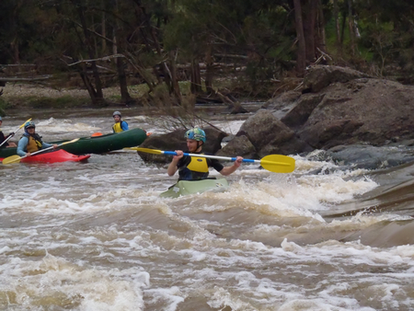
Purpose: This trip will cater for both novices and those with previous experience.

For novices the purpose of this trip is to develop skills in river running, negotiating rapids up to grade 2 and in safety aspects.

More experienced paddlers will be further developing skills in paddling techniques, rolling and bracing, reading rapids and also rescue and recovery techniques.

Skills developed may be used towards SIS19 qualifications via Recognition of Prior Learning (RPL). This weekend and subsequent trips are well suited to venturers completing Outdoors or Pursuits badges. Under the new award scheme, sections of Paddling skills can be completed at levels 5-8.

For a sample of what to expect, see short videos at: https://youtu.be/5aBRzuI6ev4 and https://youtu.be/1Jw-Gy_hxjA and https://youtu.be/WonY1qqy_cI

Location: the location of the activity will be dependent on river levels in the preceding week. Ensure email address is shown clearly on the E1 to allow final trip details to be readily communicated.

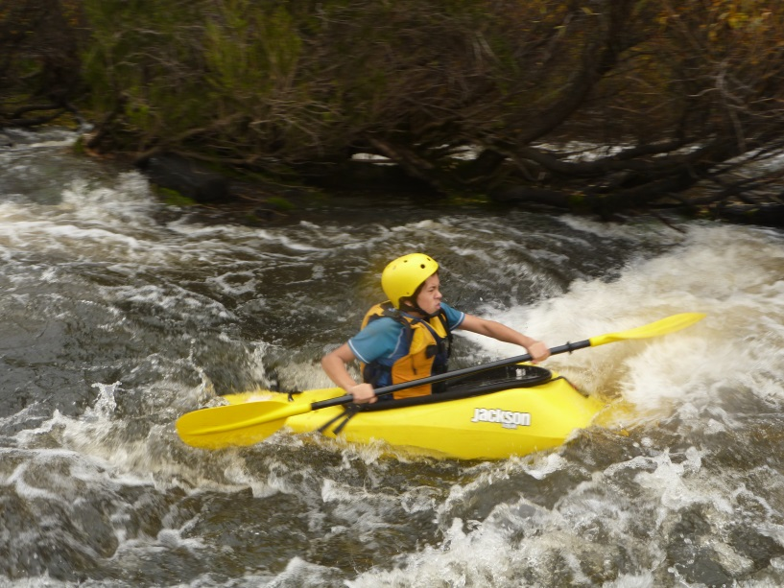
Option 1: Murrumbidgee River at Childowla. This river has reasonably reliable flows due to an upstream dam (Burrinjuck Dam). It is a much bigger volume river than the others. This drive is approximately 300 km each way.

Option 2: Murrumbidgee River in Canberra. Some larger drops suitable at moderate river flows. This drive is 260 km each way.

Option 3: Barrington River near Gloucester. This drive is 320km each way.

Option 4: Shoalhaven River at Oallen Ford. This river is good at river levels between 0.75m and 1.2m. This drive is approximately 170 km each way.

Because of distances involved in this activity, car pooling is suggested. Some seats may be available in leader’s cars. Note: Covid restrictions may impact the ability to car pool.

Detailed driving instructions will be provided in the week preceding the event, once a location has been decided.

What to bring: this activity is self cater. Ensure you bring plenty of hearty food to warm you after a long day in/on the river. Bring tenting, sleeping gear, cooking equipment, toiletries, first aid kit, camp chair. Warm clothing, kayaking gear including water shoes and thin wet suit (recommended).
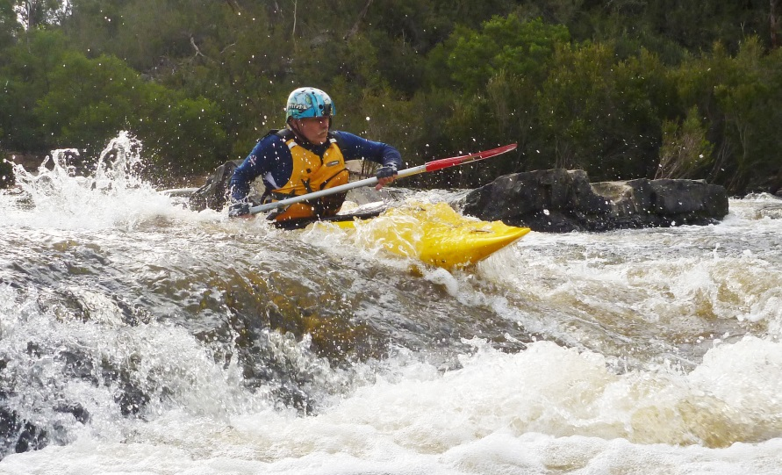
Water shoes must be firm fitting and unable to be pulled off in fast moving water.

Canberra & Barrington campsites have shower facilities, other sites are bush camping sites, with no facilities (including no toilets).
Most camping gear can be rented at nominal rates from region activities if required. Contact the activity coordinator if required (at least 2 weeks in advance preferred).

What’s provided: a range of kayaks, skirt, helmet, PFD (life jacket). Instruction.

Cost: $50, includes equipment and any camping fees. If you have your own kayak and paddling equipment then cost is $30. Please indicate on your E1 form if taking this option. (Inflatables, sit on tops and rafts are not suitable. Kayaks must have flotation and foot rests. Fiberglass craft are generally not suitable due to high likelihood of damage).

Note: a fuel contribution is required, expect $30-$60 depending on location and number attending. Pay the driver.

Note: for this activity to proceed we must have a minimum of 6 participants.
Please ensure that the boxes for 50m swim, swimming and water activities are ticked on the E1 form.

For further information contact:
Glenn Austin (Aussie), Ph: (H) 4647 1726 (M) 0417 272 978, glenn.austin@nsw.scouts.com.au
Or
Neville Austin (Nifty), Ph: (AH) 0400 432 361, nifty.activities@gmail.com

