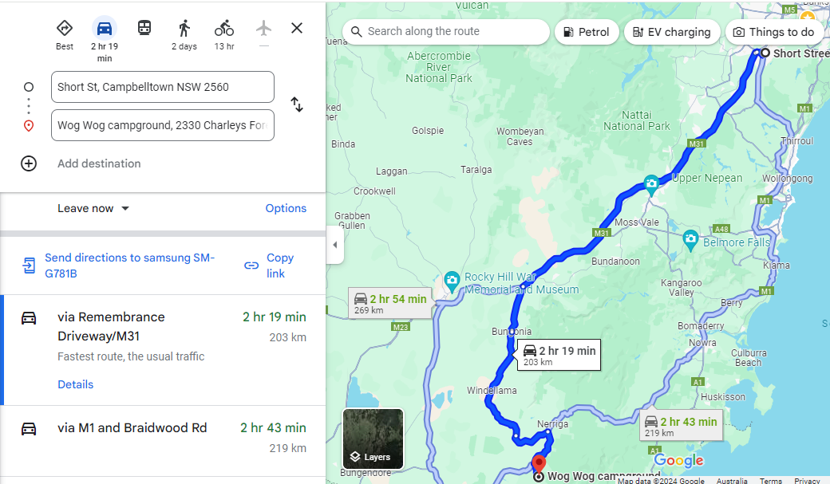

https://www.google.com/maps/dir/Short+St,+Campbelltown+NSW+2560/Wog+Wog+campground,+2330+Charleys+Forest+Rd,+Wog+Wog+NSW+2622/@-34.6107604,149.8596858,9z/data=!4m14!4m13!1m5!1m1!1s0x6b12eef8764ad245:0xdb276381dbcd43d5!2m2!1d150.8146573!2d-34.0651379!1m5!1m1!1s0x6b1431e5113cad97:0xcc930e19033cfdbe!2m2!1d150.0355738!2d-35.2682129!3e0?entry=ttu

