

To All Jamborette Attendees,

Welcome to Jamborette 2026! We hope that you are ready to have a great time with our “Our World, Our Planet, Our Future”!

We do need to be as strict as past years as this year will be a whole new experience for us all. We still need to be mindful of the health & safety of all our members. To better utilise Scheyville National Park, we have changed the camping Arrangements and locations this year.

Please take a read of the below A-Z of Jamborette 2026 and let me know of any questions or problems.

Thanks, and see you at Jamborette.

Brett Nicholas
Camp Chief
Activities

Activity Bases
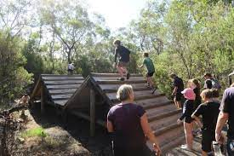 | There are heaps of fun activities to do at Jamborette this year! We have adventurous activities, scouting activities, mind games, wide games, science games and so much more! Oh and did we mention there is a prize for completing most of the bases on the weekend?  All activity base leaders must attend a mandatory briefing at HQ on Saturday morning at 8.30am Sharp.

Adventurous Activities
Some of our activities are classed as “Adventurous”. This means that there is a higher element of risk, but don’t worry, we have trained leaders on hand to help you. To do these activities, you need to make sure that you have permission to undertake them. If you have ticked the boxes on your e-permission form – you are good to go! If not, and you need help, let us know. We are running different sessions over the weekend. You will get a ticket to your session. Don’t lose it. | 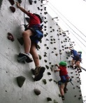

Night-time Entertainment
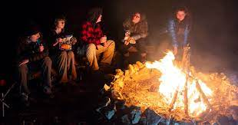 | At night, we will have movies, discos, and campfires to entertain you all.

Parades
No more standing at the back trying to hear!  This year, all our parades (Opening on Saturday Afternoon and Closing on Monday Afternoon) will take place at the mini arena. This means you will be able to fill in the circle and hear what is going on. You only need to wear your uniform to closing parade, but you only need a scarf for opening parade. | 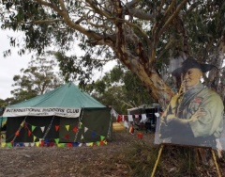

Patrols
 | You will go around Jamborette this year in patrols. Each patrol will have a Patrol Leader and 3-7 other youth members, including up to 2 Assistant Patrols Leaders! Your patrol may be your normal patrol from your unit, or a project patrol made up for the camp. Your Unit Council will setup your patrols and provide more information for you closer to camp. Patrol leaders will need to come to HQ on Saturday morning and register their patrol. You will receive a sign in sheet on Friday night from your leaders.

Scout Youth Council (SYC)
Each district will have its own Scout Youth Council. This is a chance for one or two members of each unit to meet up with other units in the district and discuss Scouts, share ideas and Plan>Do>Review> district activities. At your District SYC, you will also elect 2 members to join in the Region SYC on Sunday afternoon at 5:00 pm at HQ. Please be at HQ by 4.45pm. | 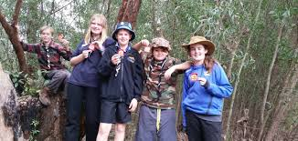

Administration

Administration Hours
 | The administration desk at Jamborette HQ is open from the following hours for general queries:  Friday – 5pm to 10pm  Saturday 8am to 7pm  Sunday 8am to 7pm  Monday 8am to 1pm  If you have a youth safety issue or an emergency, you can come up to Admin at any time. If we are not there, there will be a sign on the door of what to do.

Cancellations, Withdrawals & Transfers
We are now at the pointy end of getting everything ready! There are packs to put together, wrist bands to print, and so much more. This means that any cancellations, withdrawals & transfers must be sent through to us as soon as possible. Any refunds for cancellations, transfers or withdrawals are on a case-by-case basis and will require medical evidence. | 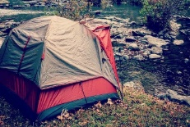

Check In Times
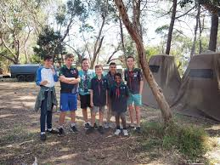 | Everyone on site must check in at Administration!  You will be required to check in on Friday night. Simply send one leader (adult) up per unit (including Venturers and Rovers) to admin with a list of who did not come to Jamborette from your registration. You will only be able to register your home unit, not all your friends’ units. They will need to attend themselves.  If you are not on site during this time, then you must report to Admin as soon as you arrive, before going to your campsite.

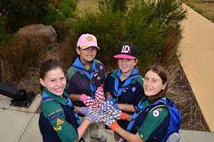
e-permissions & Payments
Now is the time to make sure everything is sorted, log on to EMS and check that everyone has completed their e-permission and has paid for Jamborette this year (If you are OK, you will have a status of accepted). All e-permissions and payments must be received by Sunday 10th May. If you are not sure, send us an email and we can check for you what needs to be done. Remember, you will have to pay your trek fees and register before you come. Otherwise, you may not be allowed to come.

Camping

Food & Catering
 | Your scout or venturer unit is responsible for your unit’s food for the weekend. It is expected that venturers will cater as a unit or join with an adjacent venturer unit. You should talk to your unit leaders about your menu, how you are going to store your food and how you will cook it. All food at Jamborette must be served by a duty patrol who will be responsible for the preparation, serving and clean up for that meal.  There will not be taps for each site as previous years. Water will be available at a central location so bring your water cans and trek carts to transport them. Sullage points will be available as well for your grey water.

Camping Locations & Campsite
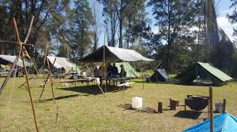
Scouts will be camping in groups based on your district. You may not be in the same location as previous years. Venturers will be camping separately. Rovers will also be Camping separately with the service leaders.
HQ will be in the officers mess building at the rear of the main courtyard.

A high standard of camping is expected at Jamborette. Sleeping in Cars and Vans on site is not permitted in the scout or venturer lines. They may be accepted in the service leaders camping area. This includes camper trailers, roof top tents.

Good Camp Hygiene
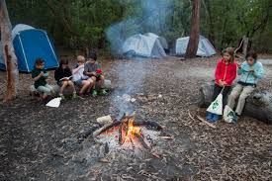 | So that we maintain good camping practices and make sure everyone stays safe, we need to make sure that we run a hygienic and well thought out camp. Make sure that you have several hand cleaning points in your site (Your gateway and your Dining Hall), are limiting the number of people who are cooking and serving food

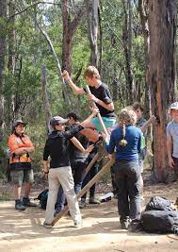
Gateway & Good Camping Awards
Each Unit is encouraged to build a gateway to their site. Your gateway can either be traditional (complete with traditional knots and lashings) or be in the theme of Our World, Our Planet, Our Future. Your Gateway needs to be able to be walked under and have a hand sanitization station included. Your gateway needs to be built by Scouts, not leaders.

We also have good camping awards for those Units who manage to keep their sites neat, tidy and show good camping principles (No leaving the fire on :P)!

Parking
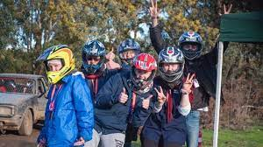 | Vehicles staying for the entire weekend are allowed to be parked on your subcamp. This is to be done in a neat and orderly way under the direction of your sub camp chief (District Scout Leader). Vehicles are not to be spread throughout campsites. If a vehicle is parked on a sub camp it must not move for the entirety of the Jamborette.  If you need to leave/return during the Jamborette you will be required to check with your district leader on where to park.  Vehicles being used to ferry equipment for activities will need a permit to move during the event. This will be only to transport gear for set up and pull down of the activity. Please contact admin for a permit.

Toilets & Amenities
The toilets and showers for event will be brought into the site for the weekend. Please make sure they are kept clean and neat.  All adults on site will be responsible for providing appropriate supervision for the amenities. This will involve mostly responding to any issues reported by your youth members.  There are separate amenities for adults and youth.  If there are any issues or concerns, please report them to Admin and we will get in contact with the sites team. | 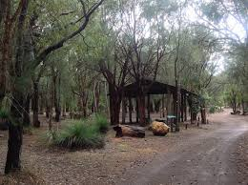

Getting To & From Jamborette

Arrival & Departure Times
 | While we appreciate that there is a lot of set up for your campsite for Jamborette, our agreement with the venue only grants us use from a set time on Friday.  Accordingly, our Jamborette team will be on site from 1:00pm. No unit is to arrive on site before 5:00pm on the Friday. Anyone arriving before this time will be asked to leave and return at 5:00pm. If you believe you need to arrive earlier for any reason, please complete the MS form in advance so I can make arrangements. Please note that having to set up marquees, dining flys or other large tents is not a valid reason for early entry to site. Campsites should be set up by youth in line with advice from leaders.  When you arrive at the camp. You will need to know what group you are in and which subcamp you are camping on. Your leader can tell you this. You will need to follow instructions from our parking team and remember, they are volunteers too. Respect goes a long way.  You will be directed to the appropriate camping site. You will have time to drop your child and wave them goodbye. If you need to stay longer with your child, you will need to park as directed by the traffic team and walk back.  Closing parade is at 1:30pm on the Monday. All units must have left site before 3:00pm when we no longer have access to the park.

Drop Off / Pick Up
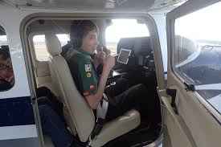 | Friday Night / Saturday Morning and Monday Afternoon are busy times for Drop off and Pick Up at the site.  To allow us to best manage the traffic in and out of the site, we ask that you arrive between 5:00pm and 9:00 pm Friday and between 8:00am and 10am Saturday. Cars for pickup will be allowed on site from 12 noon Monday.  This year we are operating a drop and kiss system with a one-way traffic flow. You will enter via the gate in Old Pitt Town Road and drop your scouts at their designated drop point. Please drop your scout as quickly as possible and move on to allow other parent/careers to drop their scouts. You will the exit via Scheyville Road. Traffic marshals will be on hand to assist with directions. Vehicles staying for the weekend or dropping trailers will be directed to their unit sites.  Pickup Monday. Upon entry to the park, parents will be directed to a parking area. Once parked you will be able to walk to your scout’s campsite and collect your scout.

Gate Hours
The main gate will close at 9pm on Friday night. On Saturday and Sunday nights, the gates will close between 7pm and 7am. If you need to leave between these hours, please make arrangements with Admin during opening hours or with the Camp Leader before the event, otherwise we cannot guarantee someone will be able to let you in/out of the park. | 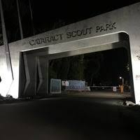

Leaving During the Weekend
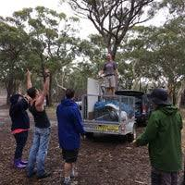 | If you are leaving camp for any reason (leaving early, supplies, work, sport, etc.), then you must report to the admin in the officers mess as you leave site and when you return. Your vehicle will need to be in the designated parking area. No vehicles to be driven out from sites.  .
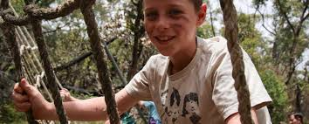
Visitors & Day Workers
Visitors to the site must check in at Jamborette HQ on Site 8 before heading to your sub-camp. When leaving site, they must also sign out. Please note that for day visitors there is an admin charge unless pre-arranged with the Camp Leader. This is so we can track who is on site in the event of an emergency as well as track attendance

Health & Safety

Adults on Site
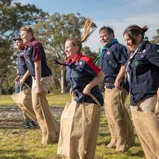 | If you are over the age of 18, you must be either a Leader, Adult Helper, Rover or Venturer registered with Scouts NSW with all mandatory modules current. If you are not, then you must not be left alone with young people and you must leave site before 11pm each evening. This is in line with NSW State Legislation and NSW Scouts Youth Protection Policy. Day workers who are not members of the association will be required to sign a Prohibited Employment Declaration (PED) upon arrival at the site.

Feeling Safe- Your Rights
Everyone in Scouts, youth and adults alike have the right to feel safe and be protected from abuse.  No-one is allowed to threaten you, hurt you or touch you in a way that makes you feel uncomfortable, unsafe or afraid. A Scout is respectful, and this applies to all interactions between all participants, youth and adults here at Jamborette.  You do not have to deal with abuse on your own. If you feel unsafe, threatened or you see/hear something that causes you concern, please speak to a Leader or Rovers on an activity. Your concerns will be taken seriously. The information you provide will be shared with people who can support and protect you.  If you don’t know what to do – speak to someone at Jamborette HQ. If, for any reason, you do not feel the concerns of this nature which you raised at Jamborette have been satisfactorily dealt with, please report your concerns directly to the Child Protection Team at the NSW State Office on Tel: 02 9735 9000 or via ChildProtection@nsw.scouts.com.au or your parents. | 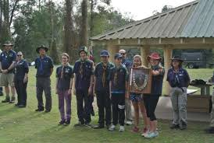  

First Aid & Mental Health First Aid
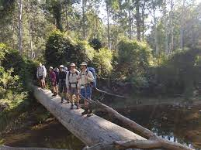 | If you get injured or hurt at Jamborette, your first stop is to speak to either the base staff (All bases should have a first aid kit) or your Unit Leader (All units should also have a first aid kit).  First Aiders and Mental Health First Aiders will be available at the camp and First Aid is always available at the officers mess near admin.  The Library – a chill out zone. Need a break? Come and hang out in the library. It’s a quiet space where you can relax, read, or do a quiet activity. Everyone is welcome from morning to close of activities. Located in the squash court in the camping area.

Medication
Please make sure that you give any medication to your leaders at the start of the camp, unless your parents have given you permission on your e-permission form to self-administer. All medication should be in a snap lock bag with your name, medication and dose clearly visible. | 

Youth Safe Advocates
 | If you do not feel safe at Jamborette, or you need someone to talk to, Youth Safe advocates are available throughout the camp. If you cannot find one, come to Admin and we will have one available for you.

What Should I Bring?

Drugs, Alcohol & Other Banned Substances
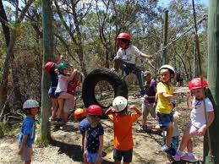 | Drugs, other than over the counter medications or those prescribed for a member attending Jamborette must not be brought to an event. When a member brings medically prescribed drugs to Jamborette, they must not provide them to any other person (except in the case of emergency when authorised by an appropriately medically qualified person or where an EpiPen is required).  Jamborette is a dry camp and Alcohol is not to be consumed on site, nor are participants to be under the effects of alcohol while on site.  Anyone smoking tobacco or tobacco-related products must be over the age of 18 and smoking must be done away from, and out of view of youth members. Each campsite/district will designate an area for smoking.

Equipment
If you are unsure on what to bring to Jamborette, have a talk to your Unit Leader about what you need to bring. At the very least you will need:  - 3 Changes of Clothes  - Mess kit.  - Something to Sleep in  - Something to Sleep on  - Torch  - Toiletries  - Towel  - Spare Pair of Shoes  - Wet weather gear  - Personal 1st aid kit  - Warm clothes  Please note that thongs, sandals, crocs and other open toed shoes are not suitable for camping. | 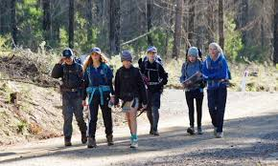

Knives
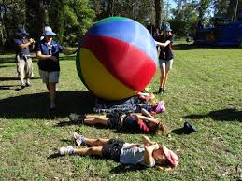 | Knives of any sort are banned at Jamborette. The only exception to this is:  - Knives used in the kitchen or as part of your mess kit.  - Saws, axes etc used to cut firewood under supervision.


Merchandise
We will have a range of merchandise for you purchase at Jamborette including:
- Previous years prizes
- Previous years badges
- Soft Drinks
- Coffee cart will operate on site8.

EFTPOS is available.

Questions?

Unplanned Changes
 | We have done everything we can to make sure you have a great time at Jamborette. With so many people on site, we are constantly refining our plans to make everything flow as smoothly as possible. As a result, some of this information may be subject to change.

Questions
If you have any questions or queries, please contact Brett (Doc) on brett.nicholas@nsw.scouts.com.au.  See you at Jamborette! | 

Photos for this pack have been sourced from Scouting Sites around Australia. Copyright belongs to the respective websites and photographers.

