How to add my Patrol for Region Rally:
Hint – this may be easier to complete with your Scout Leader and Patrol on your Section Night.
- Navigate to the Hunter & Coastal Region Rally Registration Page - https://events.nsw.scouts.com.au/event/2368
- Click on the “Login to Register” button. Use the username and password you would have created when you originally registered for the event.
- Click on the “ Add Patrol” button.

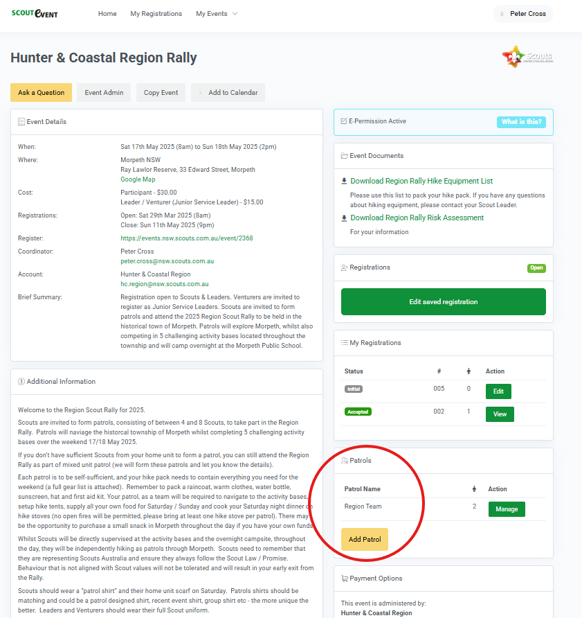

- A popup window will open (see below). The person logged in will automatically be made the Patrol Administrator (this means that they can make changes to the patrol). Click “Add”.
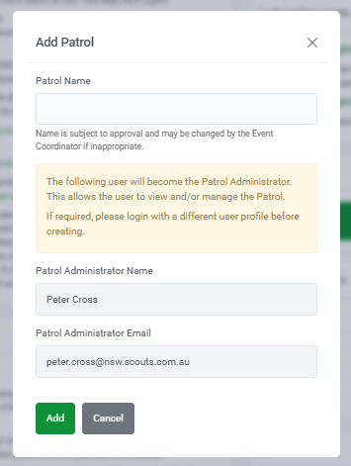
- The Patrol Member window will open.
  - Click on “Patrol Member Requests” tab.
  - Click “+ Add”
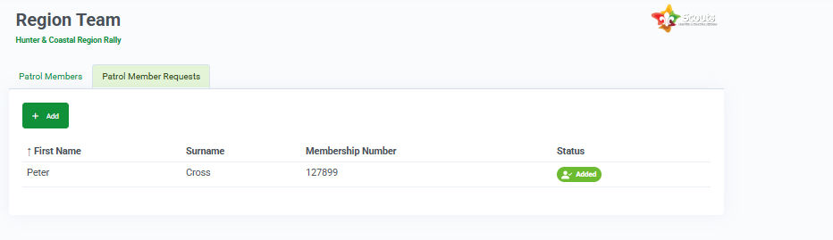

  - Enter the first name, surname and membership number of the patrol members you want to add. Your Scout Leader can help you with the membership numbers. Once finished click Save & New to add another member or Save & Return if you are finished.
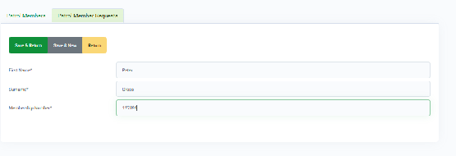
If the patrol member has completed their registration it will show a green icon “Added” under Status.

If the patrol member has not competed their registration, or perhaps you have entered their membership number incorrectly, or they have entered the membership number incorrectly on their application a Yellow icon “Not yet registered for event” will appear under Status.

To Fix:
- Ask the patrol member to complete their registration online.
- Edit the request to include the correct membership number
- Ask the patrol member to login to their application and correct the membership number.
- If the problem persists, please send me an email peter.cross@nsw.scouts.com.au and I will try to help.

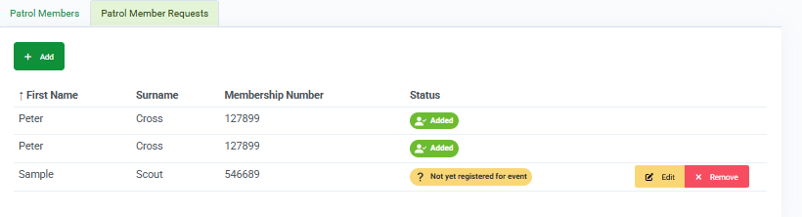

- Click on Patrol Members tab, tick one of the patrol members and click the Assign Patrol Leader button.
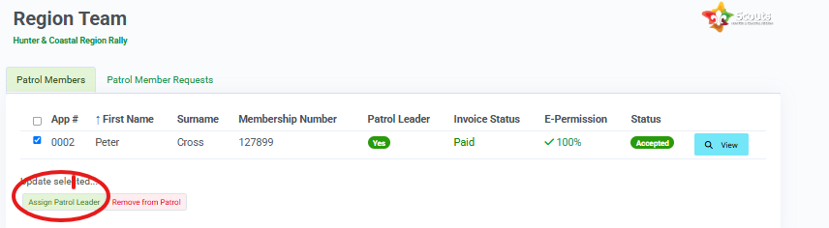

Thank you. You have now completed the registration of your Patrol for Region Rally.

