South Met Snow Trip



2025

round Robin

General Information

- Each base will be staffed by one or more Guides.
- The Patrol Leader will lead their Patrol to each base at the designated time.
- There will be 15 minutes travel time between bases, an opportunity to practice skiing skills.
- The activity at each base takes 30 minutes.
- A base location map will be supplied; it will give general location only, due to changeable weather/snow conditions.
- The base location will be identified by an orange marker pole with attached red flag, a guide will be nearby.

 | Activity | Equipment | Guide running activity
Base 1 | Weather & Risk Assessments | Cloud poster | Nigel Macdonald
Base 2 | Snow caves | Snow shovels x 4 | Anthony Schnabels
Base 3 | Snowball | Snow, This document | Chris Ward
Base 4 | Emergency Shelters | Snow shovel, snow saw, bothy bag, bivy bag | Max Kitson
Base 5 | Blind Leading the Blind | Black out goggles (10 pairs), hand line, Large bed sheet | Glenn Stalgis
Base 6 | Handball | Cones, bean bag | Maddie / Bri
Base 7 | Snow camping | Tent, snow shovel, stove etc. | Craig Scott
Base 8 | Avalanche Awareness | Snow shovel, probes, ice axe,  Go – No Go Poster | Matthew Godbold

2023 | Weather Risk Assessments | Snow caves | Snowball |  | Emergency Shelters | Blind Leading the Blind | Handball |  |  | Snow camping | Avalanche Awareness
 | Base 1 | Base 2 | Base 3 |  | Base 4 | Base 5 | Base 6 |  |  | Base 7 | Base 8
08:00/08:30 am | Arriving at Pipers Gap & getting organised
08:30/08:45 am | Before you go anywhere
08:45/09:00 am | Flat Movement Skills/ Up the hill going to bases
09:00/09:30 am | Patrol 1 | Patrol 2 | Patrol 3 | Patrol 4 | Patrol 5 | Patrol 6 |  |  |  | Patrol 7 | Patrol 8
09:45/10:15 am | Patrol 7 | Patrol 8 | Patrol 1 | Patrol 2 | Patrol 3 | Patrol 4 |  |  |  | Patrol 5 | Patrol 6
10:30/11:00 am | Patrol 5 | Patrol 6 | Patrol 7 | Patrol 8 | Patrol 1 | Patrol 2 |  |  |  | Patrol 3 | Patrol 4
11:15/11:45 pm | Patrol 3 | Patrol 4 | Patrol 5 | Patrol 6 | Patrol 7 | Patrol 8 |  |  |  | Patrol 1 | Patrol 2
11:45/12:00. pm | Basic Downhill as returning to lunch
12:00/12:30 pm | Lunch
12:30/12:45 pm | Diagonal Stride as returning to bases
12:45/01:15 pm | Patrol 2 | Patrol 3 |  |  | Patrol 4 | Patrol 5 |  | Patrol 6 | Patrol 7 | Patrol 8 | Patrol 1
01:30/02:00 pm | Patrol  4 | Patrol  5 |  |  | Patrol 6 | Patrol 7 |  | Patrol 8 | Patrol 1 | Patrol 2 | Patrol 3
02:15/02:45 pm | Patrol 6 | Patrol 7 |  |  | Patrol 8 | Patrol 1 |  | Patrol 2 | Patrol 3 | Patrol 4 | Patrol 5
03:00/03:30 pm | Patrol 8 | Patrol 1 |  |  | Patrol 2 | Patrol 3 |  | Patrol4 | Patrol 5 | Patrol 6 | Patrol 7
03:30/03:45 pm | Going Faster on the way back to cars
4:00 pm | Return to Alpine Centre

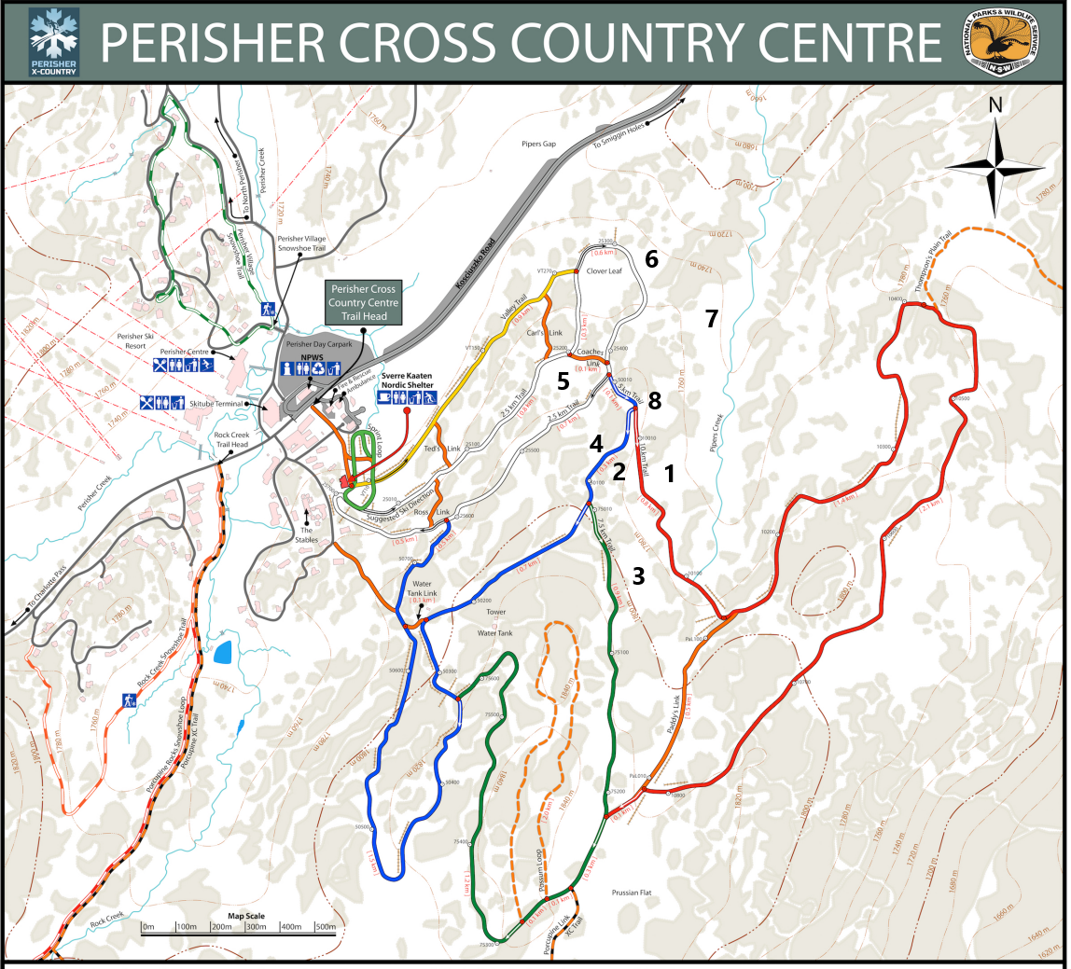

Base1

Weather

The Alpine environment can be extreme, variable and unpredictable. Altitude and temperature are very interconnected, for every 1,000-metre rise in altitude there is a 6.5°C drop in ambient air temperature in the troposphere. It occurs because the atmosphere is not warmed directly by the sun, but by heat radiated from the earth’s surface and distributed by conduction and convection.

Forecasting Weather
Bureau of Meteorology (BOM) use computer weather models as their main tool to forecast weather
Weather pattens such as El Niño's, La Niña, Indian Ocean Dipole, Southern Annular Mode to help us understand the weather.
El Nino is weather pattern there is typically a below average snow season with warn day temperatures.
La Niña, usually brings above-average rainfall. Temperatures can sometimes be too high for snow, so it rains.
The Southern Annular Mode (SAM) relationship with snowfall is a good indicator.
Negative SAM brings the fronts, rain and snow further north.
Positive SAM these fronts move further south. Unfortunately, accurate forecasts for SAM are still only possible for two to three weeks ahead.
The weather patterns over Australia generally move from west to east. They start way down south in the Antarctic. It is easy to track the pressure fronts as they move towards Australia.
East Coast Lows (ECL) can develop rapidly just offshore .ECLs may also develop in the wake of a cold front moving across from Victoria into the Tasman Sea. In winter ELCs can bring very large amounts of snow very quickly, the snow is often very heavy as the air temperature can be relatively high.
Don't get too excited by early snowfalls, early season isn't always the guide to a good season.

Plan
It is important in the planning stage of your trip to have any understanding of the type weather you can expect at the time of year above 1200m.
Be flexible with your trip itinerary. It may be better to cut the trip short rather than battle into a blizzard. Sometimes it is prudent to remain in camp rather than moving on in bad weather, even if that means being a day overdue.
You should check the long-range forecast two weeks out and be ready to adjust your trip to your plan B. (if you stay below the tree line the environment is much kinder).
At one week out the forecasts are usually quite accurate. Sometimes however the speed of an upcoming front may speed up or slow down a little.

Do
Once you have started your trip you may no longer be able to assess current weather forecasts, therefore you will have to rely on your ability to understand the weather around you.

Wind
Winds getting stronger from the north indicate that a strong change is approaching. The northerly wind will shift to a westerly then to a south-westerly.
If the wind is from the south, facing into the wind will show that the low pressure is to the east, and so moving away, the weather is likely to be improving.
Wind direction spirals outwards from highs (where air is sinking and warming) and inwards to lows (where air is rising and cooling). Wind travels clockwise around lows and anticlockwise around highs. Thus, if you face into the wind, the low is on your left. Usually, a strong northerly wind can indicate that a cold front is on the way, and conversely, a cold southerly wind heralds improving weather.

Clouds
Clouds bear moisture and hold secrets to the weather ahead. Not all clouds bear rain, you will need to develop an understanding of which ones do!
There are three main cloud levels: high, mid and low.
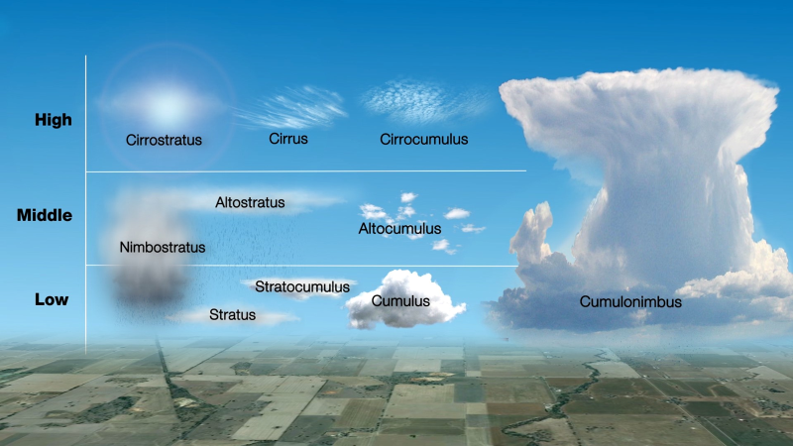
In southern Australia, high-level clouds, such as cirrus or altocumulus, moving in from the west may indicate an approaching frontal system that could arrive in the next 12 to 36 hours.
A high-flying aircraft leaving long-lasting contrails in the air indicates relatively high levels of moisture, also a forewarning of potential bad weather coming from the west.
Mid-level fluffy cotton-ball cumulus clouds may appear during sunny afternoons, sometimes large cumulonimbus thunderheads can develop.
High, thin and wispy clouds called cirrus indicate the end of fine weather, with a change approaching. By watching the movement of cirrus clouds, you can tell from which direction weather is approaching.
Bad weather is born out of temperature changes in low level, large fluffy clouds called cumulus. Storms are born out of really large cumulus clouds called cumulonimbus.

Air Pressure
Atmospheric air pressure is an indicator of weather.
When a low-pressure system moves into an area, it usually leads to cloudiness, wind, and rain or snow
High-pressure systems usually lead to fair, calm weather.

Base 1

Why do we do Risk Assessments?

Hazard identification helps us run better, safer activities.
- Recognising hazards means you can control the risk.
- Creating awareness of a hazard means control the risk.
- Setting risk management standards means you can control the risk.
- Being proactive instead of reactive means you can control the risk.

What are hazards?
A hazard is a source or a situation with the potential for harm.

How do we remember to think about everything? Break in down.

Environment
  - Weather
    - Heat
    - Cold
    - Lightning
    - Natural disasters (e.g., storms, fire, floods etc.)
  - Animals and insects.
  - Noxious plants.

Mechanical
  - Traffic and pedestrian management
  - Equipment - Are you using the correct equipment for the task
  - Stored energy – Stove fuel, water
  - Manual lifting
  - Collision with solid objects or other skiers

Personal
  - Communication- are instructions clear
  - Ability
  - Fitness.
  - Anger, temper issues
  - Separation from the group

What is risk?
A risk is the chance of something happening that will have a negative effect. The level of risk reflects:
- the likelihood of the unwanted event
- the potential consequences of the unwanted event.

What are controls?
Controls are the measures put in place to decrease the likelihood or consequences from an unwanted event.

Causes and types of Nordic Ski injuries
Risk factors include,
- fatigue
- poor condition of ski tracks
- downhill parts of the terrain
- unsuitable equipment
- poor balance
- inadequate mastery of skiing technique.

Safety tips for cross-country skiing
- Good preparation is important
- Undertake pre-season conditioning and training to build fitness, strength and flexibility
- Always warm up and cool down
- Good ski technique will help prevent injury
- Take snow conditions into consideration.
- Know your limitations.
- Look for hazards such as deep tracks, ruts, icy patches and sharp bends
- Take rest periods and eat and drink at regular intervals

Alpine & Nordic Responsibility Code

Regardless of how you enjoy your snow sport, always show courtesy to others and be aware that there are risks in all snow recreational activities that common sense, protective equipment and personal awareness can reduce. These risks include rapid changes in weather, visibility and surface conditions, as well as natural and artificial hazards such as rocks, trees, stumps, vehicles, lift towers, snow fences and snowmaking equipment.
- Stay in control and avoid other people and hazards.
- Use appropriate protective equipment, especially helmets, to minimise the risk of injury.
- You must have the ability to use each lift safely. If in doubt, ask the lift attendant.
- Obey all signs and warnings and keep off closed trails and areas.
- It is your responsibility to avoid and give way to people below and beside
- Do not stop where you are not visible from above or where you obstruct a trail.
- Before starting downhill, or merging into a trail, look uphill and give way to others.
- Use care to prevent runaway snowboards.
- If you are involved in or see an accident, alert and identify yourself to Resort Staff.
- Be aware that it is dangerous to ski, board or ride lifts if your ability is impaired by drugs or alcohol.

The Australian Ski Patrol Association (ASPA)

Nordic Specific Responsibility Code
- Always ski in control.
- Give way to skiers coming downhill
- Keep left and ski in the preferred direction.
- Give-way to other skiers when entering a trail or starting downhill.
- Do not obstruct or walk on ski trails.
- Ski only on groomed or marked trails that are within your ability.
- Do not ski alone in remote areas.

Australian Professional Snowsport Instructors Inc. (APSI)

Base 2

Snow-caves/Quinzee

Snow-cave
For a snow-cave you need to find snow that is about 2m deep, on a slope at least 35degreis but not under a cornice.
Quinzee on the other hand require a flattish site with average snow caver.
The cave entry should be mid slope to upper slope.
This does two things for you, as you dig it is easier to just push the snow down the slope and your entrance does not tend to fill up with snow as much if it does snows.
- Using an avalanche probe check the snow deep.
- As you dig the entrance check the snowpack, check at different levels as you dig down, does the snow compact into a tight snowball or does it remain in individual crystals? We need snowballs.
- Two entries are better than one
  - Two groups of people digging is faster
  - Once completed two entries gives cross air ventilation
- Dig up from your mid slope starting point.
- When you are higher than the top of the entry tunnel start digging back and up.
- Make a platform to squat, this makes the digging easier.
- Hollow out the inside and dig up to form a bell shape, you want to start as low as you can and work up. This will allow you to make a sleeping platform higher in the cave with a foot well at the entrance. With the sleeping platform sitting at a higher elevation than your entrance, this will trap the hot air in the cave this is key to keeping warm.
- It is very important to make sure the inside of the bell shape roof is smooth, or water will collect in the low points and drip on you, every annoying.
- Always take a snow shovel inside the cave just in case you need to dig out
- Mark entry with skies
- Mark that your snow cave is there, people do not ski over it.
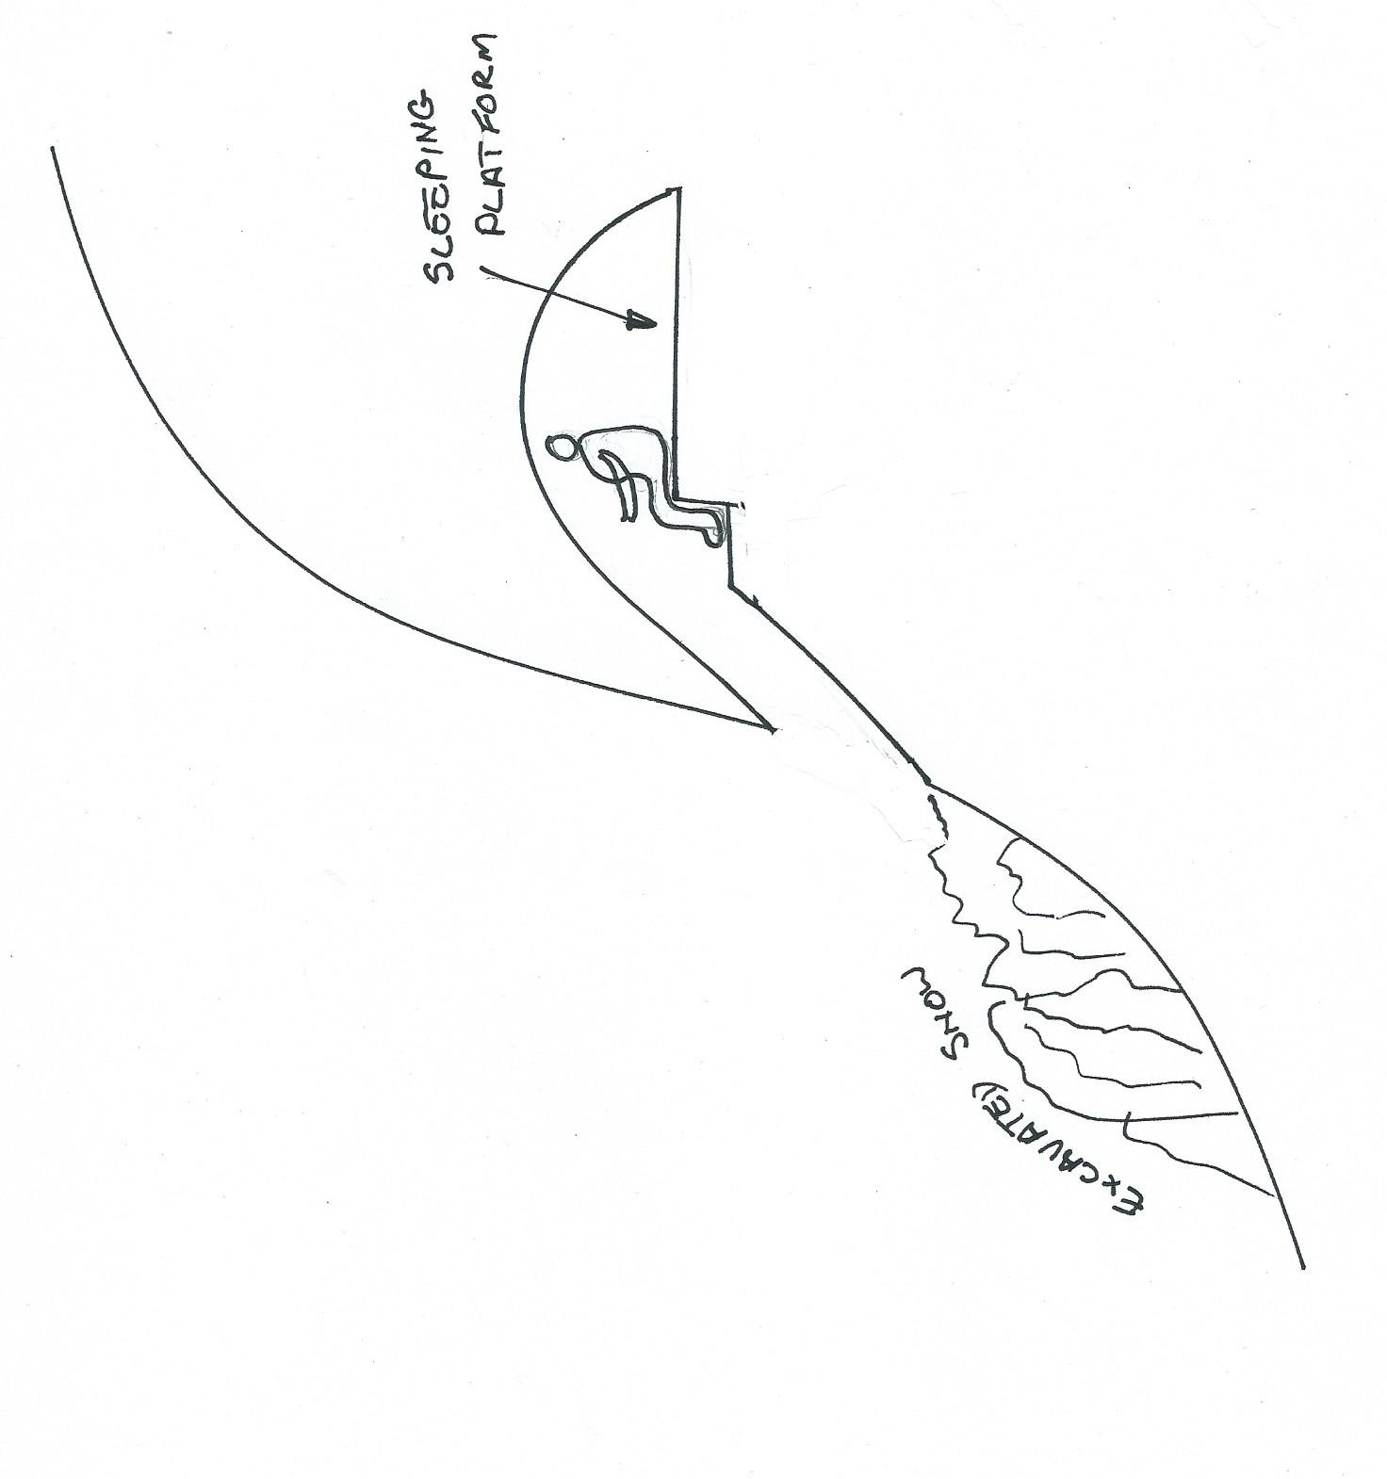

Quinzee
A quinzee is a large pile of loose snow that is shaped, then hollowed.

- Pick a sheltered location, fairly flat with good availability of snow.
- You may choose to build your quinzee into a wind scow snowbank, this many save you some work pilling snow.
- Figure out just how big your quinzee needs to be to fit everyone then add at least 500mm all round, that'll be the diameter of your quinzee.
- Shovel snow onto your marked out area making conical dome shape
- Locate your entrance on the down-wind side and cut in your entrance. Try to keep it as small as possible; just big enough to crawl through.
- Start digging. Keep digging until you can see light coming through the snow of the walls. Snow is translucent enough that even when it is about 300mm thick, you'll be able to see sunlight coming through. A thickness of at least 300mm is required for the walls & ceiling.
- Once the basic shape has been created you can get fancy, dig a foot well, table, sleeping platform, storage areas.
- As with snow-caves think about ventilation, if you put a vent in the ceiling thing about its location, will it drip on your gear, will snow blow in?
- As with a snow-cave low points will drip, put the time in at the digging stage and smooth the ceiling.

Base 3

Snow balls, Snow fights and Snow types

This activity covers the different types of snow.

Studies of the Sámi languages of Norway, Sweden and Finland, conclude that the languages have anywhere from 180 snow- and ice-related words and as many as 300 different words for types of snow

Informal classification
- Corn snow – Corn snow is coarse, granular snow, subject to freeze-thaw.^{[26]}
- Crud – Crud covers varieties of snow that all but advanced skiers find impassable. Subtypes are (a) windblown powder with irregularly shaped crust patches and ridges, (b) heavy tracked spring snow re-frozen to leave a deeply rutted surface strewn with loose blocks, (c) a deep layer of heavy snow saturated by rain (although this may go by another term).^{[39]}
- Packing snow – Packing snow is at or near the melting point, so that it can easily be packed into snowballs and thrown or used in the construction of a snowman, or a snow fort.^{[40]}
- Slush – Slush is substantially melted snow with visible water in it.^{[41]}
- Snirt – Snirt is an informal term for snow covered with dirt, especially where strong winds pick up topsoil from uncovered farm fields and blow it into nearby snowy areas.
- Spring snow – Spring snow describes a variety of temperature and moisture conditions with corn snow.
- Sugar snow – As the name implies. Sugar like course grains totally loose and not compacted. Unstable and hard to ski on or climb.

Wind-induced
- Cornice – Wind blowing over a ridge can create a compacted snowdrift with an overhanging top, called a cornice. Cornices present a hazard to mountaineers, because they are prone to break off.^{[26]}
- Finger drift – A finger drift is a narrow snow drift (30 cm to 1 metre in width) crossing a roadway. Several finger drifts in succession resemble the fingers of a hand.^{[27]}
- Pillow drift – A pillow drift is a snow drift crossing a roadway and usually 3 to 4.5 metres (10–15 feet) in width and 30 cm to 90 cm (1–3 feet) in depth.^{[28]}
- Sastrugi – Sastrugi are snow surface features sculpted by wind into ridges and grooves up to 3 meters high,^{[29]} with the ridges facing into the prevailing wind.^{[30]}
- Snowdrift or Drift tail – Snowdrifts are wind-driven accumulations of snow deposited downwind of obstructions.^{[31]}
- Wind crust – A layer of relatively stiff, hard snow formed by deposition of wind blown snow on the windward side of a ridge or other sheltered area. Wind crusts generally bond better to snowpack layers below and above them than wind slabs.^{[32]}
- Wind slab – A layer of relatively stiff, hard snow formed by deposition of wind blown snow on the leeward side of a ridge or other sheltered area. Wind slabs can form over weaker, softer freshly fallen powder snow, creating an avalanche hazard on steep slopes.^{[32]}

Sun or temperature-induced
- Firn – Firn is dense, granular snow, which has been in place for multiple years but which has not yet consolidated into glacial ice.^{[33]}
- Névé – Névé is a young, granular type of snow which has been partially melted, refrozen and compacted, yet precedes the form of ice. This type of snow is associated with glacier formation through the process of nivation.^{[34]} Névé that survives a full season of ablation turns into firn, which is both older and slightly denser.^{[33]}
- Penitentes – Penitentes are snow formations, found at high elevations, which form of elongated, thin blades of hardened snow or ice up to 5 meters in height, closely spaced and pointing towards the general direction of the sun. They are evolved suncups.^{[35]}
- Suncups – Suncups are polygonal depressions in a snow surface that form patterns with sharp narrow ridges separating smoothly concave quasi-periodic hollows. They form during the ablation (melting away) of snow from incident solar radiation in bright sunny conditions, sometimes enhanced by the insulating presence of dirt along the ridges.^{[36]}
- Yukimarimo – Yukimarimo are balls of fine frost, formed at low temperatures on the Antarctic Plateau during light or calm winds.^{[37]}

Ski resort classification
- Base snow – Snow that has been thoroughly consolidated.
- Frozen granular – Snow whose granules have frozen together.
- Loose granular – Snow with incohesive granules.
- Machine-made – Produced by snow cannons, and typically denser than natural snow.
- New snow – Snow that has fallen since the previous day's report.
- Packed powder – Powder snow that has been compressed by grooming or by ski traffic.
- Powder – Freshly fallen, uncompacted snow. The density and moisture content of powder snow can vary widely; snowfall in coastal regions and areas with higher humidity is usually heavier than a similar depth of snowfall in an arid or continental region. Light, dry (low moisture content, typically 4–7% water content) powder snow is prized by skiers and snowboarders.^{[38]} It is often found in the Rocky Mountains of North America and in most regions in Japan.^{[26]}
- Spring conditions – A variety of melting snow surfaces, including mushy powder or granular snow, which refreeze at night.
- Wet – Warm snow with a high moisture content.

Base 4

Emergency shelters

The aim
- Getting out of the weather into an enclosed, protected space.
- Choose a sheltered location on a lee slope, not at the bottom of slope that may avalanches or under a cornice that collapse.
- Consider would it be quicker and easier to descend below the snowline where a bush shelter can be built?
- What is the easiest and most effective snow shelter that can be built?
- What equipment and materials that are available to construct the shelter?
- What size do you need to build?
- Options for a shelter,
  - Trench
  - Pit
  - Tree pit
  - Bothy Bag

Show four ways to signal for help
- Phone
- Whistle
- SOS flag/orange sheet/orange bin liner
- Mirror
- Fire/smoke
- SPOT
- PLB

List four emergency items to take on a snow trip
Ten Essential Systems is always a good place to start.
- Navigation: map, compass, altimeter, GPS device, personal locator beacon (PLB) or satellite messenger
- Headtorch
- Sun protection: sunglasses, sun-protective clothes, sunscreen and lip balm.
- First aid: including foot care
- Knife: plus a gear repair kit
- Fire: matches, lighter, candle end and/or stove
- Shelter: always carry (emergency blanket)
- Extra food: Beyond the minimum expectation
- Extra water: Beyond the minimum expectation
Extra clothes: Beyond the minimum e

Base 5

Blind leading the Blind

First Activity
Leapfrogging along a bearing, slow but it works, just don’t ski of a cornice!
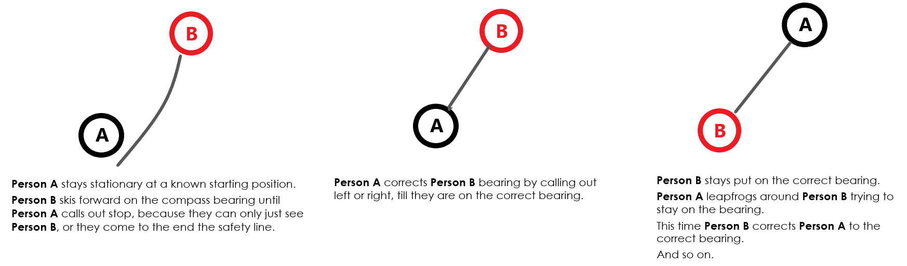

Second Activity
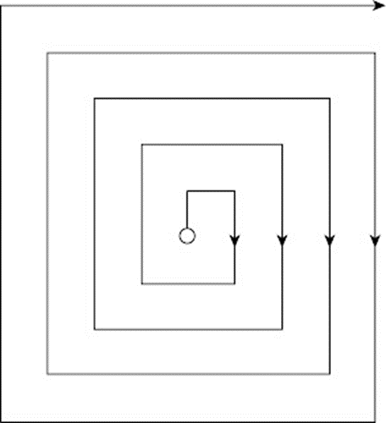
Expanding Square Search and Rescue (SAR)
A common search pattern, called the expanding square. Which is just what it says it is. You travel along calculated route legs in a pattern that expands every 3rd leg, so you systematically cover the search area in an expanding pattern. The travel distance can be as short as a step, useful if you have lost the tent in a white out when you when for a wee.

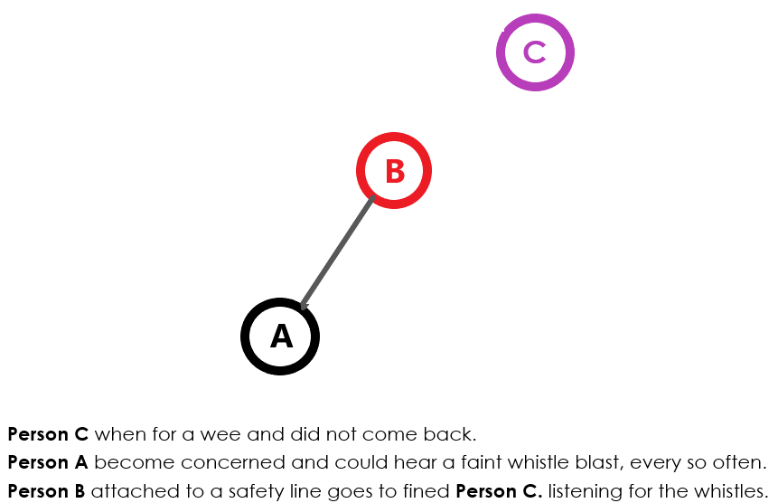
Third Activity
Fine the lost Person in a white out.

What do you do when the weather changes?
- Stop
- Take a compass bearing to your next known point on your trip card or if you can no longer see this point any other features you can identify on your map.
- Ask the patrol what they think, what have they noticed. Discuss.
- Relate this and your bearing, to your attack point and features on the map to get a fix.
- If proceeding use bad weather navigation techniques
Bad weather navigation (Leapfrog)
- Select the bearing you are going to ski on, and both set your compasses to this bearing
- The lead person, goes off on this bearing and skis to within a limit of visibility, stops and turns around.
- The second person takes a bearing on the lead person. If the bearing has been correctly followed the rear person puts an arm up vertically.
- If the course needs correcting the rear person points which direction the lead person must move.
- When the lead person is in the correct position the rear person again raises their arms. The lead person confirms the signal by raising both arms vertically, upon which the rear person walks to the lead person.
- Repeat.
Faster not so Bad weather navigation (Three-person line)
- Select the bearing you are going to ski on and set your compasses to this bearing.
- The lead person, who should be the most accomplished navigator, leads off on this bearing
- The second person, who need not be a navigator, follows in the footsteps of the leader, some distance behind.
- The third person, who is a navigator, follows using their compass to check the bearing, looking ahead at the two skiers to see if they are in line with each other.
- The leader skier needs to stop at regular distances, at which point the rest of the group should stop immediately.
- If the bearing has been correctly followed, the rear person puts an arm up vertically. If the course needs correcting, the rear person indicates which direction the lead person must correct to.
- When the lead person is in the correct position, the rear person again raises their arms. The lead person confirms the signal by raising both arms up, upon which the group start skiing again. Repeat.
Rules for navigation in bad weather
- Decide if you really need to keep moving or is it safely to stay put.
- Continually review your progress on the map, does it make sense? Use all the tools available to you, altimeter, GPS.
- Use back markers.
- Remember to use good navigation methods,
  - Aiming off.
  - Handrails
  - Collection Features, what have you passed, what are you about to pass?
  - Catch Features, back stop after your attack point.
- Use ‘Leapfrog’ or a ‘Three-person line”.
- Keep the group together at a steady pace.
- Concentrate and lead with calmness.

Base 6

Handball

Mark out a court with the cones, it needs to be about10 metres wide and 30 metre long. Size it not critical, you may just have it make it work.

General
- 5 players or so and 1 goalie
- The game will start with a through up ball at centre court.
- Games will consist of two 10-minute halves.
- A goal is scored once the entire ball has crossed the line.
Ball handling
- Players are not allowed to move with the ball.
- Players must pass to another teammate or attempt a shot on goal
- Players are only allowed to hold the ball for 5 seconds without moving when closely guarded by a defender.
- A drop ball will result in a free for all.
Out of bounds
- Once the ball goes over the sidelines it is out of bounds and is awarded to the opposing team at the point it went out.
- On a throw-in, the ball must be passed to a teammate before a shot on goal can be attempted (i.e. no direct shots on goal from out of bounds).
- All defenders must stay back at least 3 feet from the in-bounder when the ball is being thrown in.

Base 7

Snow-camping

Location is crucial.
- Pitch your tent in the lee of a hill, or in amongst some snow gums, this will help with the wind.
- Don’t pick a location below a cornice or in an avalanche area.
- Think about the wind, which way the wind is likely to come from. Pitch the door of the tent away from the wind.
- Think about the tent locations for the rest of the patrol, can they easily be located in a whiteout? How are you going to walk to the camp kitchen area, to the toilet area?
- Create a flat platform for your tent by,
  - stamping down the snow
  - leveling with a ski
  - waiting a while for it to harden.
- Snow pegs are very useful, if you don’t have any you can bury sticks in the snow with the guy rope tided mid-way along or use your skies.
- Snow shovels are great for building a wall around your tent, digging a camp kitchen, digging seats foot well in your tent.

Tips for cooking in the snow
- Keep it simple.
- Remember fuel is heavy but you don’t want to run out. Take extra fuel, because you may need to melt snow for water.
People have different opinions on the best stove for snow camping. Most argue that a liquid fuel stove (e.g. shellite) is best, because gas stoves don't perform as well in cold conditions. However, other people say that Jetboil are fine.
- Cooking in tent vestibules is generally not advised. That's because of the risk of carbon monoxide poisoning which can kill you. However, the reality is that if the weather is bad, most people cook in the vestibule, just make sure the vents are open. Place the stove in the foot well to increase the vertical clearance above the stove, because stoves can flare, and you want the tent fabric to be well away from any flames. It may be possible it light the stove with the tent door open just using the tent as weather protection. Tent is made of highly flammable synthetic materials, which, will melt if exposed to hot items. So, bear that in mind when your handling pot and pans. Cooking inside a closed vestibule creates large quantities of steam and moisture, which will condense inside your tent. To help control this open vents completely while cooking. This is very important, because one of the biggest tasks, when it comes to winter camping, is to keep everything dry for as long as possible.
- Going to the toilet while snow camping, as with any toileting scenario in the bush, be mindful of where you're going. Digging a hole in the ground may not be as easy as it sounds especially if there is a metre of snow above the ground and it is frozen. The best and easiest way to go is a poo tube. Just do your business in a compostable bag tie it off and place in the tube it’s that easy.
- Don’t forget to stand up your skies and to slip your pole straps over there tips, saves a lot of time next morning looking for ski es if it snows.

In its simplest terms a poo tube is a length of pipe with a blank cap one end and screw cap the other.
As with everything there are pros and cons to different designs.

This is my favorite setup, and I will explain why.

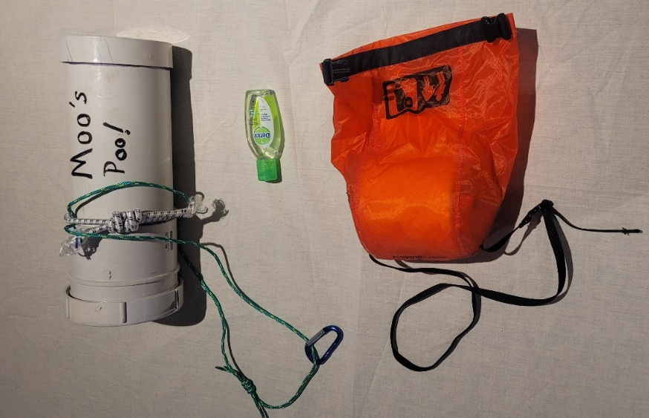

- 100mm sewer pipe, 300mm long
100mm because I squat on the pipe with a compostable kitchen bin liner draped over the top. Once the job is done, I simply pull the bag up off the pipe and tie it off, simple. I have tried 90mm stormwater pipe but found it a little small for my aim, yours may be better than mine.300mm seems to be a nice high from the ground for me and it holds about 5 days at max. Note the strong elastic cord around the tube is to hold it whilst transporting (don’t want you to lose your poo), I normal pass a pack strap under this elastic, the thin green cord mainly used in a canoe to tie the tube in.
100mm is heavier than 90mm but I think it is worth the extra weight.
- Waterproof toilet holder with strap. For many years I used a zip-lock bag, but this is a vast improvement. You can put the hand sanitizer and the compostable bags, in the toilet paper holder to keep your toileting kit altogether.
- Hand sanitizer because you my not have any water to wash your hands.
- Compostable bag, store in a zip-lock bag.

Disposal
The reason for using compostable bag is to enable the tube to be easily emptied into any pit toilet. Once the compostable bag gets wet it will start to breakdown, so by the time it is pumped out the bag is gone.

Base 8

Avalanche Awareness

Avalanches are rare in Australia, but they do happen. Here is a list of some of the more notable ones.
- Kunama Huette on 12th July 1956 was struck by an avalanche from Mt Clark run directly into the hut, knocking it off its foundations and destroyed it. Roslyn Wesche, one of 11 people in the hut was killed. Hers was the third ski death in NSW.
It resulted from unusual conditions. Previous weather had caused a hard icy surface to form on the snow. Then came 45 cm of dry snow from the south-east, instead of the usual west. As a result, a large cornice formed on Mt Clarke which collapsed to start the avalanche.
- 2008 Tom Carr Boyd died when a cornice collapsed at Mt Twynum and set off an avalanche near Blue Lake.
- 2014 two snowboarders, Martie Buckland and Daniel Kerr, died in an avalanche on Mt Bogong in the Victorian Alps.
So, if you are going to play in the mountains, please be avalanche aware

Types of Avalanches
There are mainly 5 types of avalanches: slab avalanches, loose snow avalanches, cornice fall avalanches, glide avalanches and wet avalanches.
- Slab avalanches cause nearly 99% of avalanche accidents. A slab avalanche is released when one of the layers underneath the snowpack collapses. It can be either triggered spontaneously (the weight of snow itself during snowfall or warm temperatures) or caused by people.
- Cornices are created by wind and can cause avalanches when collapsing.
- Glide avalanches occur when the whole snowpack lets go and glide along the ground.
- Loose snow avalanches start in one place when a small amount of snow collects more and more snow while sliding down.
- A wet avalanche is released by the water built up inside the snowpack and the powerful slushy snow can even move stones on the way down.
Slab and cornices avalanches are the two biggies.

Steepness and identifying avalanche terrain
The biggest indicator of avalanche terrain is the angle or degree of the slope, avalanches occur when the degree of the slope is at least 25degrees.
Typically, most of the avalanches are set off when the degree is between 30-45 degrees. The risk reduces when the angle is 55 or steeper, probably because it is too step for snow to build up. The most efficient way to reduce avalanche risk is to stay on slopes less than 25 degrees. But keep in mind that even if you are on more gentle terrain, avalanches may occur above you or you could set one off by standing on a slab that is connected to the steeper part. Keep an eye on the terrain above and around you!
Most avalanches start on unforested slopes or those with a dispersed tree cover on angles between 30 and 45 degrees. Thus, if there are no slopes within this range above a site, and the area is heavily forested, it is probably not avalanche terrain. Many avalanche paths are confined to gullies and natural drainage channels. However, avalanches can also occur on broad open unconfined slopes.
After the steepness, orientation (or the direction the slope is facing) is one of the most significant factors affecting avalanches. Orientation affects the temperature of the slope, for example on north easterly faces temperature can differ throughout the day: sun warms up the snow during the day which freezes overnight, creating icy layers. The direction of the slope helps you to define how winds have affected it, and whether the winds have stacked dangerously much snow on the face during snowfall. Most cornices are on the leeward side of hill, that is the eastern side in NSW because the prevailing wind is from the northwest.
Wind and stacked snow. Heavy winds, especially during snowfall, stack snow to sheltered places and create dangerous slabs, which can be released easily.
The best way to minimize risks is to avoid avalanche terrain and stay in areas and mountain faces less than 25 degrees.

Avalanche safety gear
The very basics for a day in the backcountry are a shovel and probe. Avalanche beacons for each person would also be nice. First aid kits are a must as well.
RECCO-reflectors are a nice addition, they are small reflector is usually attached to your helmet, clothes or boots. These small reflectors can only be located by ski patrols and mountain rescuers.

Probe
The probe is a lightweight, metallic and collapsible pole, which is used to find the exact location of the buried person.

Shovel
A good snow shovel is sturdy, metallic and collapsible to make sure that it easily fits into your backpack.

Beacon
An avalanche transceiver (or beacon) is used to transmit and receive signals. With this small and handy device, you can find the buried person, or you can be found.

