2025 South Met Scouts Snow Spectacular

Handbook

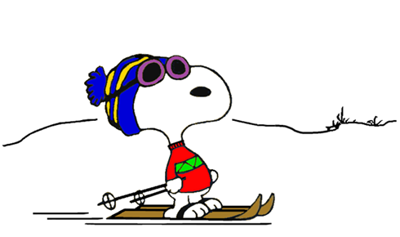
Perisher Cross Country Ski Trails
We will be Cross country skiing at the Perisher cross country ski trails. We will have activity station around the trails where persons can participate in Snow Games, Learn survival skills for Alpine touring, Snow craft and avalanche awareness and Alpine navigation.
Snow Shoeing
We have a limited number of Snowshoes for those wanting to try this sport. We recommend that you hire your own snowshoes from Rhythm sports at Cooma. All snowshoers will be accompanied by NSW state appointed Snowshoe Guides

South Met Snow trip
Program

22/08/2025 | Friday Evening
10:15 pm | Arrive Jindabyne Alpine Centre
10:45PM | Curfew lights out Alpine Centre
23/08/2025 | Saturday
6:00 am | Rise and shine Up and breakfast
6:15 am | Good morning and welcome to the school, introductions | Patrol Leaders and Guides intro
7:00 am | Cars and bus depart Jindabyne
7:45 am | Arrive Perisher Pipers Gap
8:00 am | Patrols rally at Pipers Gap
8:15 am | Basic lessons begin activities on snow
12:00 pm | Lunch
12:45 pm | Begin circuit activities
4:00 pm | Depart for Jindabyne
5:00 pm | Arrive Jindabyne and free time
6:30 pm | Dinner
7:00 pm | Dinner finish and presentation
8:15 pm | Free time for some – paperwork, folios for others.
9:00pm | Bed time start of curfew
9:30pm | Lights out
24/08/2025 | Sunday
6:00 am | Rise and shine Up and breakfast
6:30 am | Personal kit moved into outside buildings/ cars. Vacate Alpine centre. Clean up and sweep centre
7:00 am | Cars depart Jindabyne
7:45 am | Arrive Perisher Pipers Gap TBC
8:00 am | Patrols rally at Pipers Gap
8:15 am | Begin activities on snow
12:00 pm | Lunch
12:45 pm | Begin activities
2:30 pm | Depart Perisher for Jindabyne
3:30 pm | Depart for Sydney from Jindabyne
4:00 pm | Arrive Rhythm snow sports Cooma / return hire kit
10:00 pm | Arrive Sydney

Frequently asked questions

Do I need to take my own mess kit
No, All cutlery and plates are provided. Please bring a lunch box for up the hill

Do I need to carry snow chains
Yes, if your vehicle is 2wd. 4wd and All wheel drives cars are not required to carry snow chains in the National Park.

Vegetarian
We cater for vegetarian.

Are there charging ports for devices
NO
Equipment Hire
You are responsible for your own skis or snowshoes. We have made the below reservations for you.
Please present these details to Rhythm snow sports at Cooma and they will be able to supply your equipment.
Preferred First Name | Your height in cm | shoe size in Euro | Ski / Snow Shoe Hire
Both Ski and Snowshoe Hire
William Kitson | 135 | 5 | I want to hire BOTH XC ski and snowshoe
Maxwell Kitson | 185 | 46.5 | I want to hire BOTH XC ski and snowshoe
James Kitson | 140 | 4 | I want to hire BOTH XC ski and snowshoe
Neil Chaudhary | 171 | 44 | I want to hire BOTH XC ski and snowshoe
Patrick Northcott | 170 | 43 | I want to hire BOTH XC ski and snowshoe
Reed Wilson | 161 | 42 | I want to hire BOTH XC ski and snowshoe
Beau Lalor | 150 | 40 | I want to hire BOTH XC ski and snowshoe
Emile Whitcher | 173 | 46 | I want to hire BOTH XC ski and snowshoe
Bernard Whitcher | 180 | 43 | I want to hire BOTH XC ski and snowshoe
Jack Cottom | 157 | 37.5 | I want to hire BOTH XC ski and snowshoe
Michael Thompson | 179 | 44 | I want to hire BOTH XC ski and snowshoe
Matilda Harris | 167 cm | 39 | I want to hire BOTH XC ski and snowshoe
Amanda Simpson | 167 cm | 42 | I want to hire BOTH XC ski and snowshoe
Tahlia King-Li | 175 | 41 | I want to hire BOTH XC ski and snowshoe
Jayden King-Li | 155 | 42 | I want to hire BOTH XC ski and snowshoe
Spencer Waldock | 187.96 | 47 | I want to hire BOTH XC ski and snowshoe
Mahee Bharadwaj | 174 | 42 | I want to hire BOTH XC ski and snowshoe
Robert De Ligt | 178 | 45.5 | I want to hire BOTH XC ski and snowshoe
Jagan Ganti | 175cm | 44 | I want to hire BOTH XC ski and snowshoe
Aditya Ganti | 155 | 42 | I want to hire BOTH XC ski and snowshoe
Snow Shoe Hire
Lachlan King | 172 | 45 | I want to hire Snowshoes
Katey King | 172 | 39 | I want to hire Snowshoes
Michael Donohue | 190cm | 45 | I want to hire Snowshoes
Russell Liauw | 175 | 45 | I want to hire Snowshoes
Adrian Mak | 149 | 37 | I want to hire Snowshoes
Ethan Yap | 170 | 44 | I want to hire Snowshoes
Charlie Edision | 151 | 37 | I want to hire Snowshoes
Edyson Solaiman | 170 | 41 | I want to hire Snowshoes
Isabelle Lee | 163 | 38 | I want to hire Snowshoes
Kaitlynn Peng | 140 | 36 | I want to hire Snowshoes
Wan Jing Fang | 170 | 40 | I want to hire Snowshoes
Xin Yiing Loo | 160 | 38 | I want to hire Snowshoes
Nichole Mak | 156 | 38 | I want to hire Snowshoes
Emily Mak | 143 | 37 | I want to hire Snowshoes
Joanna Lin | 148 | 34 | I want to hire Snowshoes

Ski only hire
Ethan Rutenberg | 159 | 41 | I want to hire XC skis NNN BC
Tyson Grace | 160 | 40 | I want to hire XC skis NNN BC
Alfie Aldred | 154 | 40 | I want to hire XC skis NNN BC
Clive Brennan | 171 | 43 | I want to hire XC skis NNN BC
Marcus Liu | 165 | 44 | I want to hire XC skis NNN BC
Kim-Maree Davenport | 159 | 37 | I want to hire XC skis NNN BC
Jemma Davenport | 168 | 40 | I want to hire XC skis NNN BC
Shaun Davenport | 186 | 44 | I want to hire XC skis NNN BC
Bryony Brennan | 174 | 42 | I want to hire XC skis NNN BC
Harry Rutenberg | 171 | 42 | I want to hire XC skis NNN BC
Amber McDonald | 153 | 41.5 | I want to hire XC skis NNN BC
Carly Davenport | 156 | 40 | I want to hire XC skis NNN BC
George De Sacadura | 170 | 41 | I want to hire XC skis NNN BC
Helen Riegman | 169 | 41 | I want to hire XC skis NNN BC
Bruce Mills | 176 | 44 | I want to hire XC skis NNN BC
Samuel Mills | 176 | 44 | I want to hire XC skis NNN BC
Bruce Lilley | 174 | 0 | I want to hire XC skis NNN BC
Glenn Stalgis | 172 | 42 | I want to hire XC skis NNN BC
Benjamin Portois | 165 | 45 | I want to hire XC skis NNN BC
Alison Crealy | 180 | 41 | I want to hire XC skis NNN BC
Mason Sutherland | 161 | 42 | I want to hire XC skis NNN BC
Lucy (Kai) Summerfield | 170 | 38 | I want to hire XC skis NNN BC
Annabelle Gallagher | 150cm | 38 | I want to hire XC skis NNN BC
Donna Fitzgerald | 154 | 40 | I want to hire XC skis NNN BC
Iwona Conlan | 170 | 42 | I want to hire XC skis NNN BC
Alice Conlan | 165 | 41 | I want to hire XC skis NNN BC
Stephen Martin | 194 | 46 | I want to hire XC skis NNN BC
Greta Martin | 162 | 40 | I want to hire XC skis NNN BC
Madeleine Ward | 160 | 39 | I want to hire XC skis NNN BC
Brianna Ward | 160 | 39 | I want to hire XC skis NNN BC
Tarn Ward | 160 | 39 | I want to hire XC skis NNN BC
Claire Buggy | 173 | 42 | I want to hire XC skis NNN BC
Liam Kwok | 155 | 41 | I want to hire XC skis NNN BC
Sean Fenerty | 160.5 | 43 | I want to hire XC skis NNN BC
Jay Ghodke | 160 | 40 | I want to hire XC skis NNN BC
Aadi Narang | 155 | 39 | I want to hire XC skis NNN BC
Catalina Gonzalez | 175 | 41-42 | I want to hire XC skis NNN BC

XC Ski Hire
We have arranged an extremely good discount at Rhythm sports in Cooma for the event. Approx $55 for hire of Cross Country boots, stocks and Skis (NNN BC) or snow shoes for the two days. Participants will be responsible for paying for their own XC ski or snow shoe hire (Ski Hire IS NOT included in the event price). Please note that this discount is not available to Scouts outside this event. We will book / reserve (but not pay) for you your XC skis and snow shoes through Rythm.

Perisher XC Ski Trails

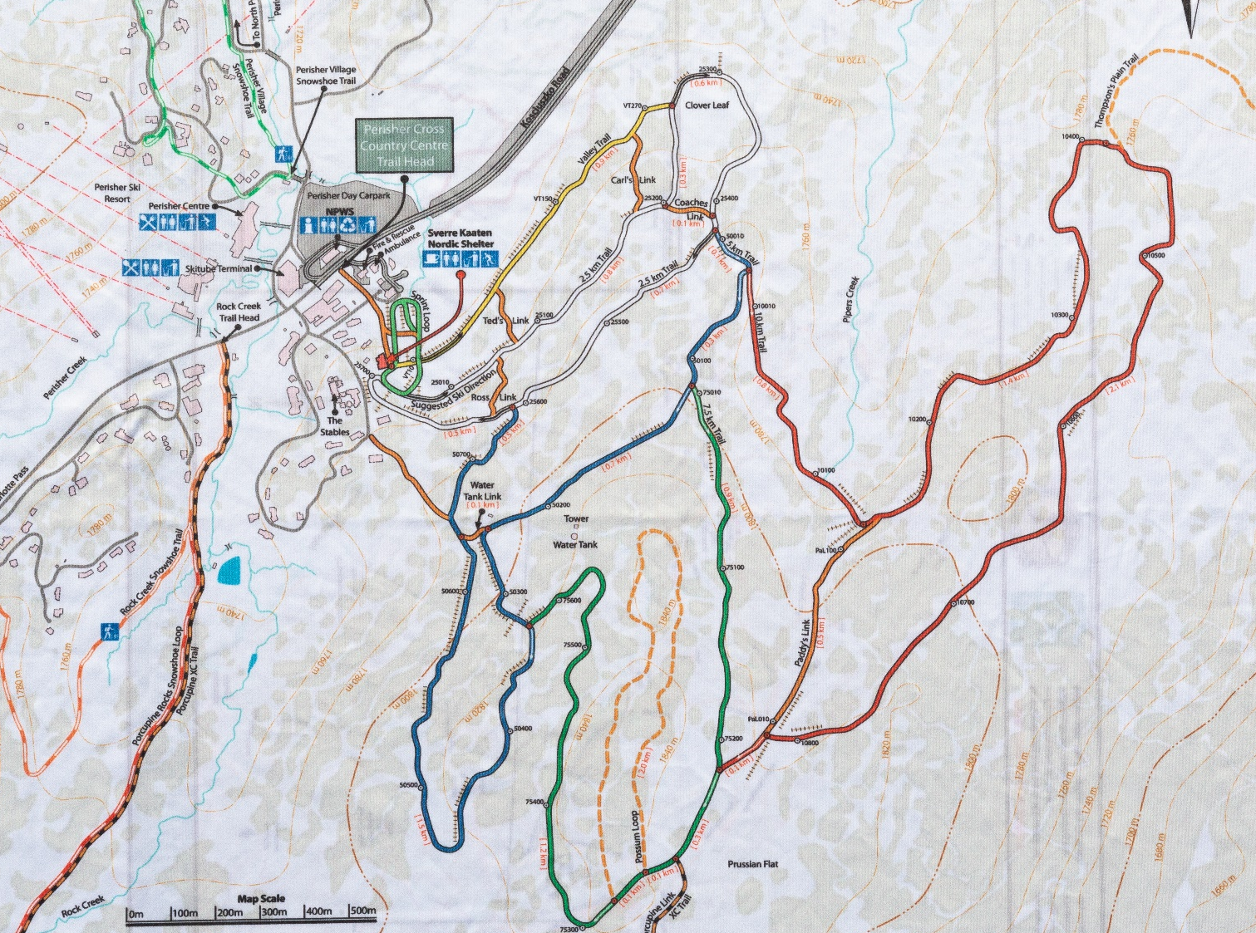

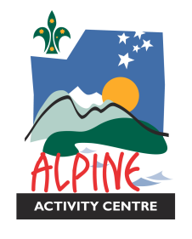
WHAT TO BRING CHECKLIST
Please make sure all your belongings are clearly labelled with your full name
What you will need for the Alpine Activity Centre – Tony Balthasar Lodge
- Single Sheet to go on the mattress (flat sheet best option)
- Doona or Sleeping Bag
- Pillow with pillowcase on
- Towel
- Toiletries
- Torch
- General clothing including warm pants, t shirts, jumpers, underwear, singlets, socks, pyjamas, shoes
- Book for quiet time

What you will need for the SNOW
- day backpack
- drink bottle
- neck warmer or Buff
- thermal pants (not cotton as it captures the moisture),
- thermal top or other under‐layer (not cotton as it captures the moisture)
- Jumper or insulation layer
- goggles
- beanie
- waterproof ski jacket
- waterproof ski pants
- light gloves and a pair of rubber washing up gloves (Large enough to go over your ski gloves, needed for making snow men and shelters).
- warm socks – min 4 pairs
- non slip warm shoes
- ski gloves
- sunglasses
- Lip balm
- Sunscreen
- Sun Hat for sunny days.
- If you have these items, please bring them along.
Snow Shovel, Small plastic tarp 3m x 3m, Small First Aid Kit, Field Repair Kit, Insulated Sitting Matt (closed cell foam 50cm x 50cm.

Patrol Allocation
Patrol | Rockhopper Penguin | Adelie Penguin | Royal Penguin | Emperor Penguin
 | XC Ski Beginner | XC Ski Beginner | Skiers - skill unknown | Skiers - skill unknown
Allocated Guide | Madeleine / Brianna Ward | Nigel McDonald (Guide) | Bernard Pfeil (Guide) | Ant Schnabels
Patrol Leader | Helen Riegman (Trainee) | Kim-Maree Davenport (Leader) | Bryony Brennan (Leader) | Harry Rutenberg (Leader)
2IC | Bernard Whitcher (Leader) (Beginner) | Shaun Davenport (Leader) | Bruce Mills (Leader) | Aadi Narang
Member | Emile Whitcher (Beginner) | Jemma Davenport | Samuel Mills | Alfie Aldred
Member | Jack Cottom (Beginner) | Carly Davenport | George De Sacadura | Amber McDonald
Member | Mason Sutherland (Beginner) | Marcus Liu | Jay Ghodke | Clive Brennan
Member | Claire Buggy | Neil Chaudhary | Liam Kwok | Ethan Rutenberg
Member |  | Patrick Northcott

Marconi Penguin | King Penguin | Fairy Penguin | Gentoo Penguin
Skiers - skill unknown | Skiers - skill unknown | Skiers - skill unknown | Skiers or Snowshoers
Maxwell Kitson | Matt Godbold | Chris Ward | Bruce Lilly
Alison Crealy (Leader) | Robert De Ligt (Leader) | Jagan Ganti (Leader) | Amanda Simpson (Leader)
Benjamin Portois | Michael Thompson(Leader) | Kai Summerfield | Catalina Gonzalez (Rover)
William Kitson | Alice Conlan | Tarn Ward | Tahlia King-Li
James Kitson | Greta Martin | Aditya Ganti | Jayden King-Li
Tyson Grace (Cherrybrook) | Stephen Martin | Annabelle Gallagher | Spencer Waldock
Mahee Bharadwaj (Cherrybrook) | Iwona Conlan | Donna Fitzgerald | Matilda Harris
 |  |  | Sean Fenerty

Patrol Allocations are for participant management during this event
Patrols may change while on the snow due to skill levels and other influencing matters.

Gentoo Penguin | Fur Seals | Weddel Seals | Leopard Seals
Skiers or Snowshoers | Snowshoers 1(a) | Snowshoers 1(b) | Snowshoers 1(c)
Bruce Lilly | David Walsh | Craig Scott | Glenn Stalgis
Amanda Simpson (Leader) | Katey King (Trainee) | Edyson Solaiman (Leader) (BLIA) | Wan Jing Fang (Leader) (BLIA)
Catalina Gonzalez (Rover) | Michael Donohue (Leader) | Aaron Grace (Helper) (Cherrybrook) | Xin Yiing Loo (Leader) (BLIA)
Tahlia King-Li | Lachlan King | Russell Liauw (BLIA) | Nichole Mak (BLIA)
Jayden King-Li | Reed Wilson | Adrian Mak (BLIA) | Emily Mak (BLIA)
Spencer Waldock | Beau Lalor | Ethan Yap (BLIA) | Joanna Lin (BLIA)
Matilda Harris |  | Charlie Edision (BLIA) | Isabelle Lee (BLIA)
Sean Fenerty |  |  | Kaitlynn Peng (BLIA)

Admin | Staff
Elephant Seals | Crabeater Seal
Admin Team
Glenne Stalgis  Chris Ward | Amanda Buggy  Paul Beitelis
 | Lachlan Scott | Kitchen
 | Craig Scott | QM / Transport
 | David Walsh | Assessment
 |  | Reserve Guides
 |  | Ben Low
 |  | Andrew Hay

Patrol Allocations are for participant management during this event
Patrols may change while on the snow due to skill levels and other influencing matters.

Bunk Allocations for
Townsend Dormitories Male
Surname |  | Room | Bed number
Martin | Stephen | Townsend Dorm | F1 | Adult
Pfeil | Bernard | Townsend Dorm | F2 | Adult
De Ligt | Robert | Townsend Dorm | F3 | Adult
McDonald | Nigel | Townsend Dorm | F4 | Adult
Thompson | Michael | Townsend Dorm | F5 | Adult
Kitson | Maxwell | Townsend Dorm | F6 | Adult
Rutenberg | Harry | Townsend Dorm | F7 | Adult
Mills | Bruce | Townsend Dorm | F8 | Adult
Ganti | Jagan | Townsend Dorm | F9 | Adult
Ganti | Aditya | Townsend Dorm | F10 | Youth
Grace | Aaron | Townsend Dorm | F11 | Adult
Grace | Tyson | Townsend Dorm | F12 | Youth
Chaudhary | Neil | Townsend Dorm | F13 | Youth
Northcott | Patrick | Townsend Dorm | F14 | Youth
Aldred | Alfie | Townsend Dorm | F15 | Youth
Brennan | Clive | Townsend Dorm | F16 | Youth
Liu | Marcus | Townsend Dorm | F17 | Youth
De Sacadura | George | Townsend Dorm | F18 | Youth
Mills | Samuel | Townsend Dorm | F19 | Youth
Kwok | Liam | Townsend Dorm | F20 | Youth
Ghodke | Jay | Townsend Dorm | F21 | Youth
Narang | Aadi | Townsend Dorm | F22 | Youth
Rutenberg | Ethan | Townsend Dorm | F23 | Youth
Kitson | William | Townsend Dorm | F24 | Youth
Kitson | James | Townsend Dorm | F25 | Youth
Mak | Adrian | Townsend Dorm | F26 | Youth
Yap | Ethan | Townsend Dorm | F27 | Youth
Edision | Charlie | Townsend Dorm | F28 | Youth
Waldock | Spencer | Townsend Dorm | F29 | Youth
King-Li | Jayden | Townsend Dorm | F30 | Youth
King | Lachlan | Townsend Dorm | F31 | Youth
Fenerty | Sean | Townsend Dorm | F32 | Youth
Lalor | Beau | Townsend Dorm | F33 | Youth
Whitcher | Emile | Townsend Dorm | F34 | Youth
Cottom | Jack | Townsend Dorm | F35 | Youth
Sutherland | Mason | Townsend Dorm | F36 | Youth
Wilson | Reed | Townsend Dorm | F37 | Youth
Portois | Benjamin | Townsend Dorm | F38 | Youth
Surname | Name | Room | Bed number
Liauw | Russell | Townsend Mezzanine | F39
Solaiman | Edyson | Townsend Mezzanine | F40
 |  | Townsend Mezzanine | F41
Whitcher | Bernard | Townsend Mezzanine | F42
 |  | Townsend Mezzanine | F43
Donohue | Michael | Townsend Mezzanine | F44

Bunk Allocations for
Kosciusko Dormitories Female
Surname | Name | Room | Bed number
Riegman | Helen | Kosciusko Dorm | M1 | Adult
 |  | Kosciusko Dorm | M2 | Adult
Crealy | Alison | Kosciusko Dorm | M3 | Adult
 |  | Kosciusko Dorm | M4 | Adult
Simpson | Amanda | Kosciusko Dorm | M5 | Adult
 |  | Kosciusko Dorm | M6 | Adult
Fitzgerald | Donna | Kosciusko Dorm | M7 | Adult
 |  | Kosciusko Dorm | M8 | Adult
Conlan | Iwona | Kosciusko Dorm | M9 | Adult
 |  | Kosciusko Dorm | M10 | Adult
Loo | Xin Yiing | Kosciusko Dorm | M11 | Adult
 |  | Kosciusko Dorm | M12 | Adult
Fang | Wan Jing | Kosciusko Dorm | M13 | Adult
Gonzalez | Catalina | Kosciusko Dorm | M14 | Adult
 |  | Kosciusko Dorm | M15 | Adult
Brennan | Bryony | Kosciusko Dorm | M16 | Adult
Buggy | Claire | Kosciusko Dorm | M17 | Youth
 |  | Kosciusko Dorm | M18 | Youth
Harris | Matilda | Kosciusko Dorm | M19 | Youth
 |  | Kosciusko Dorm | M20 | Youth
King-Li | Tahlia | Kosciusko Dorm | M21 | Youth
 |  | Kosciusko Dorm | M22 | Youth
 |  | Kosciusko Dorm | M23 | Youth
McDonald | Amber | Kosciusko Dorm | M24 | Youth
 |  | Kosciusko Dorm | M25 | Youth
Bharadwaj | Mahee | Kosciusko Dorm | M26 | Youth
Conlan | Alice | Kosciusko Dorm | M27 | Youth
Martin | Greta | Kosciusko Dorm | M28 | Youth
Gallagher | Annabelle | Kosciusko Dorm | M29 | Youth
 |  | Kosciusko Dorm | M30 | Youth
Lee | Isabelle | Kosciusko Dorm | M31 | Youth
Lin | Joanna | Kosciusko Dorm | M32 | Youth
Mak | Nichole | Kosciusko Dorm | M33 | Youth
 |  | Kosciusko Dorm | M34 | Youth
Peng | Kaitlynn | Kosciusko Dorm | M35 | Youth
 |  | Kosciusko Dorm | M36 | Youth
Mak | Emily | Kosciusko Dorm | M37 | Youth
 |  | Kosciusko Dorm | M38 | Youth
Surname | Name | Room | Bed number
Summerfield | Lucy | Kosciusko Mezzanine | M39

Bunk Allocations for Rooms 1 to 4
 | Name | Room | Bed number
First Aid / Contingency bunk |  | Room 1 | R1A
Contingency bunk |  | Room 1 | R1B
 |  | Room 1
Buggy | Amanda | Room 2 | R2A
King | Katey | Room 2 | R2B
Contingency bunk |  | Room 2 | R2C
Contingency bunk |  | Room 2 | R2D
Stalgis | Glenn | Room 3 | R3A
Beitelis | Paul | Room 3 | R3B
Contingency bunk |  | Room 3 | R3C
Contingency bunk |  | Room 3 | R3D
Late arrivers (Cherrybrook)
Davenport | Shaun | Room 4 | R4A
Davenport | Kim-Maree | Room 4 | R4B
Davenport | Jemma | Room 4 | R4C
Davenport | Carly | Room 4 | R4D
 |  | Room 4 | R4E

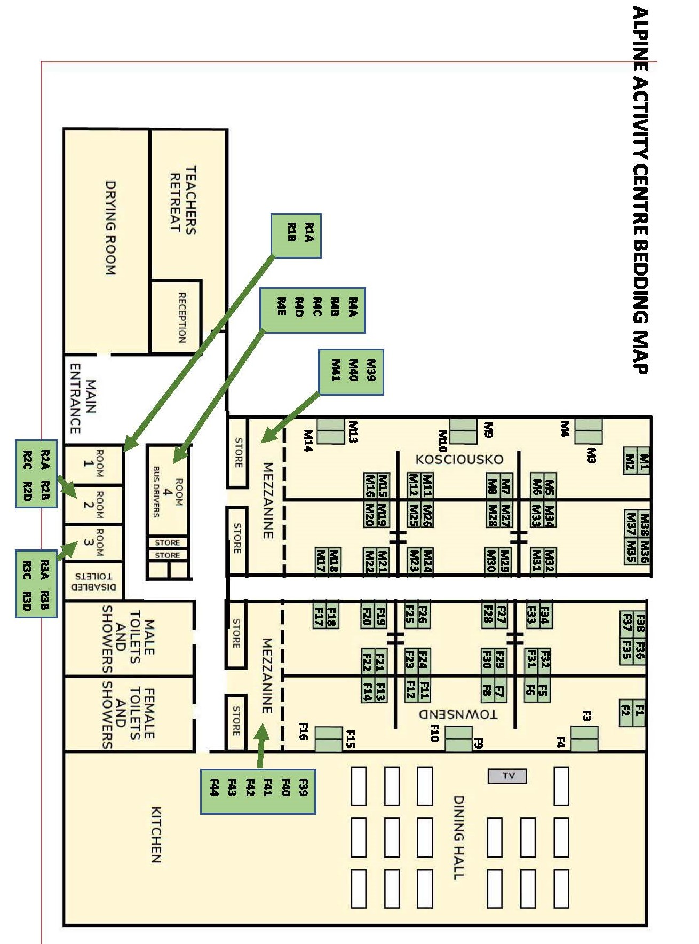
Lesson Plans for XC skiers
Lesson 1A.  Equipment familiarisation.  Boots. Skis. Poles.  - Boots-Correct fitting  - Skis-Grip zone,  - Ski-Glide zone  - Skis-Edges.  - Poles-Straps how to adjust and use.  Don boots, skis and poles.  - Check Bindings Work.  - Ensure, pole grip is correct. | Lesson 1B.  Flat skills and stance.  - Bent knees,  - Ankles and body form a vertical line  - Toes-Knees-Nose (Tony Knows)  - Legs are shock absorbers  Fall and recovery.  - Fall sideways onto bum-Dead Ant.  - Skis across the slope.  - Body uphill, on to the knees.  Balance and stand
Lesson 2.  Check stance, Toes-Knees-Nose  Practise fall and recovery as per lesson 1b.  - Balance on one ski.  - Sidestep.  - Step over poles,  - Start turns.  - Reverse star turns  - Snow brushing  - Hops,  - Kick turns. | Lesson 3.  - Walking to striding  - Striding to gliding  - Gliding with poling  - Change direction.  - Double polling.  - Uphill diagonal stride.  Optional game : Pass the Banana
Lesson 4.
Skills Consolidation and movement
- Herring bone
- Sidestepping,
- Side slipping.
- Snow plough glide and break.
- Step turn.
- Snow plough turn
optional game : Slalom Race.

